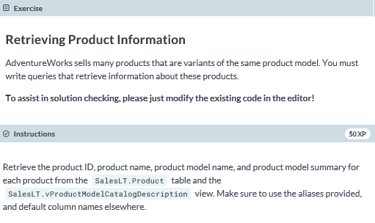

**-- select the appropriate columns from the appropriate tables**

**SELECT P.ProductID, P.Name AS ProductName, PM.Name AS ProductModel, PM.Summary**

**FROM SalesLT.Product AS P**

**JOIN SalesLT.vProductModelCatalogDescription AS PM**

**-- join based on ProductModelID**

**ON P.ProductModelID = PM.ProductModelID**

**ORDER BY ProductID;**

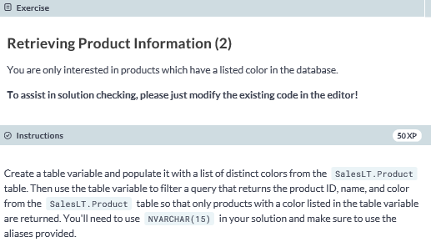

**DECLARE @Colors AS TABLE (Color NVARCHAR(15));**

**INSERT INTO @Colors**

**SELECT DISTINCT Color FROM SalesLT.Product;**

**SELECT ProductID, Name, Color**

**FROM SalesLT.Product**

**WHERE Color IN (SELECT Color FROM @Colors);**

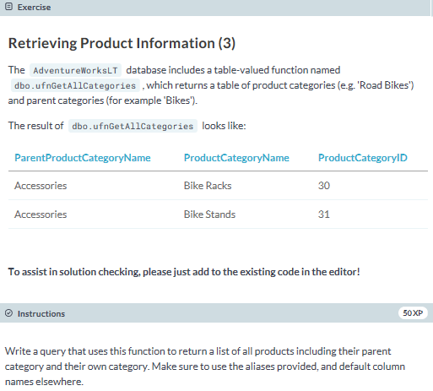

**SELECT C.ParentProductCategoryName AS ParentCategory,**

**C.ProductCategoryName AS Category,**

**P.ProductID, P.Name AS ProductName**

**FROM SalesLT.Product AS P**

**JOIN dbo.ufnGetAllCategories() AS C**

**ON P.ProductCategoryID = C.ProductCategoryID**

**ORDER BY ParentCategory, Category, ProductName;**

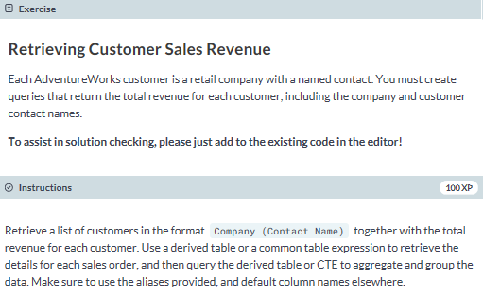

**SELECT CompanyContact, SUM(SalesAmount) AS Revenue**

**FROM**

**(SELECT CONCAT(c.CompanyName, CONCAT(' (' + c.FirstName + ' ', c.LastName + ')')), SOH.TotalDue**

**FROM SalesLT.SalesOrderHeader AS SOH**

**JOIN SalesLT.Customer AS c**

**ON SOH.CustomerID = c.CustomerID) AS CustomerSales(CompanyContact, SalesAmount)**

**GROUP BY CompanyContact**

**ORDER BY CompanyContact;**